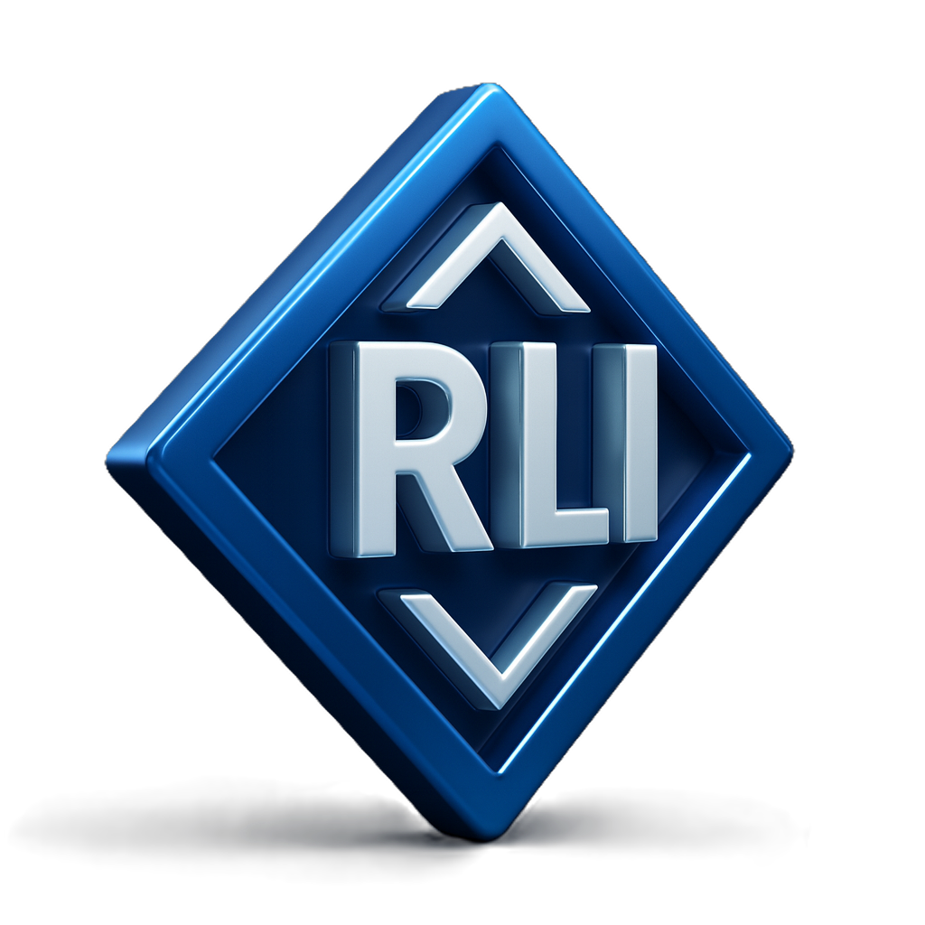
RELY’ON LEARNING INSTITUTE
COMPUTER SCHOOL

Privacy Policy
Effective Date: November 1, 20025
Relyon Learning Institute (RLI) values your privacy. This policy explains how we collect, use, and protect your information when you visit our website or use our learning services.

1. Information We Collect
We may collect:
- Personal details such as your name, email address, and contact number when you register, enroll, or contact us.
- Payment details when you purchase a course or service (processed securely through trusted third-party providers).
- Non-personal data like browser type, device, and usage patterns to help us improve our site experience.

2. How We Use Your Information
We use your information to:
- Register you for courses or services.
- Process payments and send receipts.
- Communicate important updates, schedules, and learning materials.
- Improve our programs and website functionality.

3. Data Protection
We use secure systems and encrypted connections to protect your personal data. Only authorized staff and trusted service partners have access to it for operational purposes.

4. Sharing of Information
We do not sell or trade your information. We may share limited data only with:
- Payment processors for billing purposes.
- Learning or email platforms used to deliver courses and updates.
- Legal authorities if required by law.

5. Cookies
Our website may use cookies to enhance your browsing experience. You can choose to disable cookies in your browser settings.

6. Your Rights
You can request access, correction, or deletion of your personal data by contacting us at info@relyonlearninginstitute.com

7. Updates
We may update this policy from time to time. The latest version will always be posted on this page with the updated date.

Contact Us
If you have any questions about this Privacy Policy, please contact us at:
Email: info@relyonlearninginstitute.com
Website: www.relyonlearninginstitute.com

